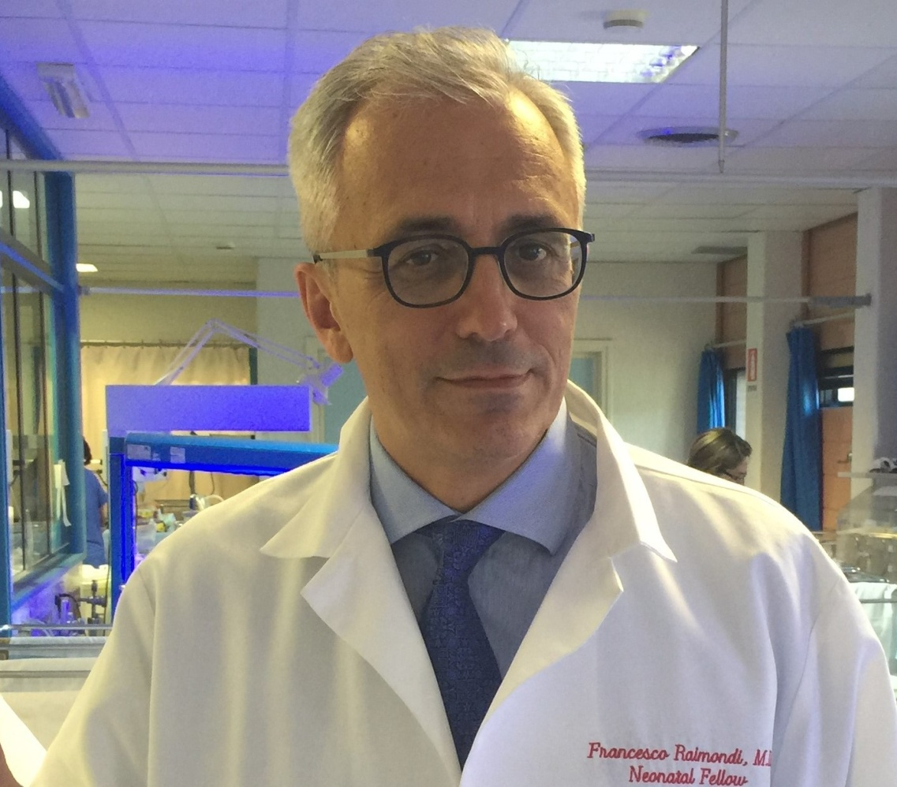

Dr Raimondi is currently Professor of Pediatrics and Chief of Neonatology at the University of Naples (Italy) where he obtained his MD and PhD degrees.

He received his basic science research training at the University of Birmingham (UK) and at the University of Chicago. He has been a Pediatric Resident and later a Neonatology Fellow at the University of Maryland at Baltimore.

His research interests in Neonatology include infection, hyperbilirubinemia, nutrition and the functional applications of lung ultrasound in neonatal respiratory medicine. He is authors of over 170 publications in peer-reviewed journals and chapters in national and international textbooks. He serves as reviewer for numerous scientific journals and is currently member of the **International Advisory Board** of NeoReviews , a journal of the American Academy of Pediatrics.

Dr Raimondi is Chairman of the charity “Soccorso Rosa Azzurro” for the advancement of Neonatology and sits on the Board of Directors of the Italian Society of Neonatology .